1. Heroku only take 3-tiers web site, not static or 2-tier web site
2. download Heroku tookbelt for windows to your local machine, then in command window , you may use heroku command
3. Create your Heroku account from [www.heroku](http://www.heroku) .com
4. Open Git shell
5. heroku login
6. Enter your Heroku credentials.
7. Email: zeke@example.com
8. Password:
9. Authentication successful.
10. Your node.js app structure shoule be like node-js-gettng-started
11. git clone https://github.com/heroku/node-js-getting-started.git
12. $ cd node-js-getting-started

11. modified your package.json file in your own app.

**Your package.json shoule includes: node version, npm version, dependencies should include: express, foobar**

**The following is an example:**

{

"name": "angular-seed",

"private": true,

"version": "0.0.0",

"engines": {

**"node": "0.12.2",**

**"npm": "2.7.4"**

},

"description": "A starter project for AngularJS",

"repository": "https://github.com/angular/angular-seed",

"license": "MIT",

"devDependencies": {

"karma": "~0.10",

"protractor": "~0.20.1",

"http-server": "^0.6.1",

"bower": "^1.3.1",

"shelljs": "^0.2.6",

"karma-junit-reporter": "^0.2.2"

},

**"main":"index.js",**

"scripts": {

"postinstall": "bower install",

"prestart": "npm install",

**"start":"node index.js",**

"pretest": "npm install",

"test": "karma start test/karma.conf.js",

"test-single-run": "karma start test/karma.conf.js --single-run",

"preupdate-webdriver": "npm install",

"update-webdriver": "webdriver-manager update",

"preprotractor": "npm run update-webdriver",

"protractor": "protractor test/protractor-conf.js",

"update-index-async": "node -e \"require('shelljs/global'); sed('-i', /\\/\\/@@NG_LOADER_START@@[\\s\\S]*\\/\\/@@NG_LOADER_END@@/, '//@@NG_LOADER_START@@\\n' + cat('app/bower_components/angular-loader/angular-loader.min.js') + '\\n//@@NG_LOADER_END@@', 'app/index-async.html');\""

},

**"dependencies": {**

**"express": "~4.9.x",**

**"foobar": "^1.1.0"**

**}**

}

**11. the project structure should has: index.js, Procfile**

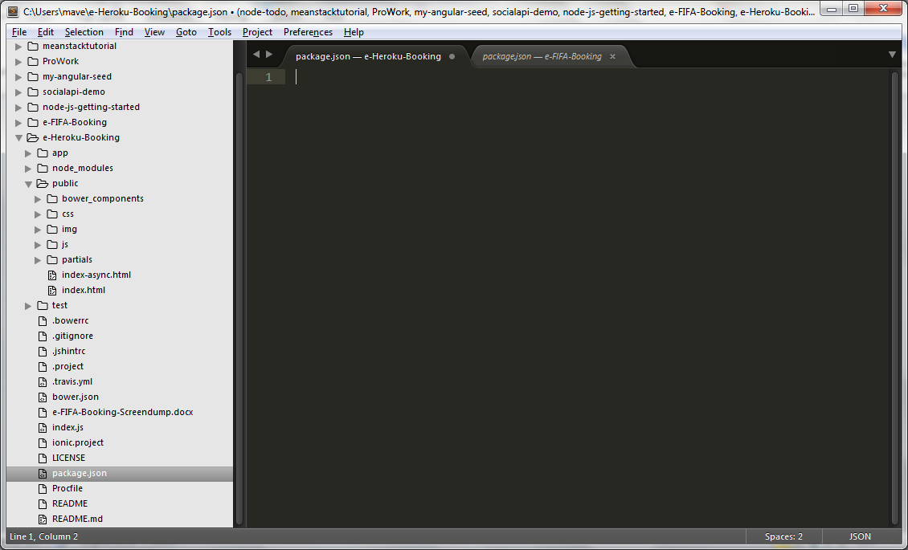

**Index.js file should be like this:**

var express = require('express');

var app = express();

app.set('port', (process.env.PORT || 5000));

app.use(express.static(__dirname + '/public'));**//This is for index.html to display**

app.get('/', function(request, response) {

response.send('Hello World!');

});

app.listen(app.get('port'), function() {

console.log('Node app is running on port', app.get('port'));

});

1. Prepare **Procfile** as following:

**web: node index.js**

1. **Put node_modules folder into .gitignore**

Means: don’t check them into github

Try following:in git shell

$echo node_modules >> .gitignore

The above line can create .gitignore file first

.gitignore file content would be like the following:

node-modules

*****************************

1. In your local machine, make sure the node version and npm version match the version showed in package.json file

15.1 how to install latest node

Go to nodejs official site and download it and install it in the dir:c://Program file(x86)

15.2 how to install latest npm version

Git shell

**$ npm install –g npm@latest**

15.2.1 following the following link to update npm version in windows

How to update npm version in Windows

<https://github.com/npm/npm/wiki/Troubleshooting>

1. Make sure node_moduels match with your package.json

Open git shell, type

$npm install –save foobar

1. If has any trouble, try to install node_moduels from blank

$ rm –rf node_modules **// remove node_modules folders**

**$npm install –quiet –production**

**$npm start**

1. Then

$ cd my app/

$heroku create

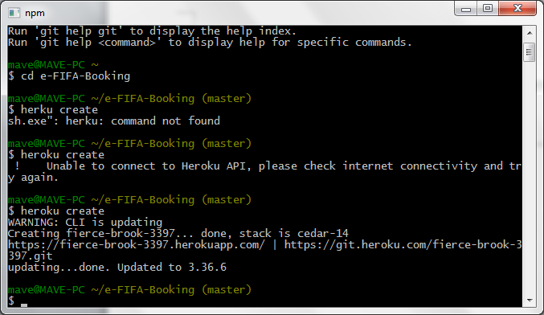

$git push heroku master

Then go to: https//arcane—sands-5312.herokuapp.com

=====================================================

The following is the link for trouble-shooting desploy node.js app to Heroku:

<https://devcenter.heroku.com/articles/troubleshooting-node-de> eploy